Class Time:
Names:

The Normal Distribution: Normal Distribution Lab II

Student Learning Outcomes:
The student will compare empirical data and a theoretical distribution to determine if everyday experiment fits a continuous distribution.
Collect the Data
Measure the length of your pinkie finger (in cm.)

- Randomly survey 30 adults. Record the lengths. Round to the nearest 0.5 cm.

- Construct a histogram. Make 5 – 6 intervals. Sketch the graph using a ruler and pencil. Scale the axes.
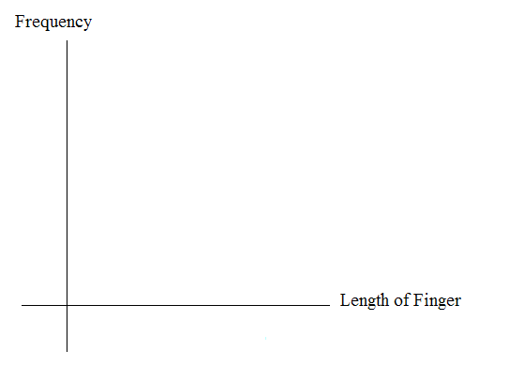
3. Calculate the following
  - = __________
  - s = __________
4. Draw a smooth curve through the top of the bars of the histogram. Use 1 - 2 complete sentences to describe the general shape of the curve. (Keep it simple. Does the graph go straight across, does it have a V shape, does it have a hump in the middle or at either end, etc.?)

Analyze the Data

Using your sample mean, sample standard deviation, and histogram to help, what was the approximate theoretical distribution of the data from Part I?

- X ∼ ____________
- How does the histogram help you arrive at the approximate distribution?

Describe the Data

Using the data in Part I (Hint: order the data):

Remember: IQR = Q3 – Q1
- The IQR goes from ________ to _________.
- IQR = ______.
- The 15th percentile is _____________.
- The 85th percentile is ______________.
- The median is ___________.
- The empirical probability that a randomly chosen pinkie length is more than 6.5 cm = _____________.
- Explain the meaning of the 85th percentile of this data.

Theoretical Distribution
Using the theoretical distribution in Part II:

- The IQR goes from _____________ to ______________.
- IQR = ___________.
- The 15th percentile is _____________.
- The 85th percentile is ______________.
- The median is ___________.
- The theoretical probability that a randomly chosen pinkie length is more than 6.5 cm = _____________.
- Explain the meaning of the 85th percentile of this distribution.

Discussion Question

- Do the data from “Collect the Data” give a close approximation to the theoretical distribution in “Analyze the Data?” In complete sentences and comparing the result in “Describe the Data” and “Theoretical Distribution”, explain why or why not.

